**MedBillDozer – Problem Framing Script**

## Scene 1 – On Camera (Opening)

Hi, I’m John. I built MedBillDozer to address a systemic weakness in healthcare — medical billing accuracy.  
  
And the data shows this isn’t a marginal issue.

## Scene 2 – 49–80% Error Rate

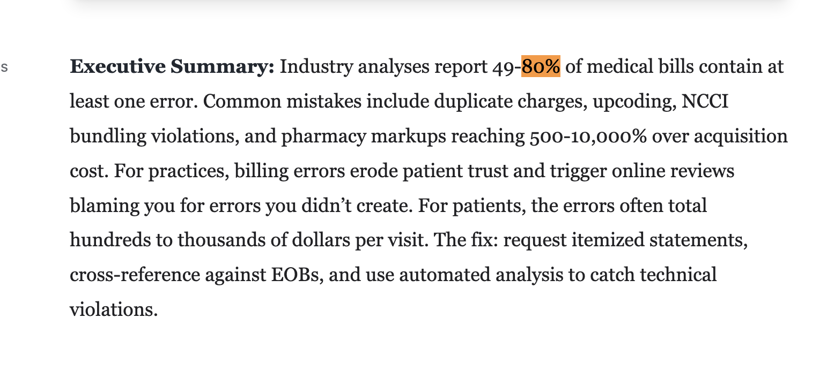

Industry analyses report that between forty-nine and eighty percent of medical bills contain at least one error.  
  
That’s not a small arithmetic error. It reflects systemic process failure.

## Scene 3 – $1,300 Average Error (ABC / Equifax)

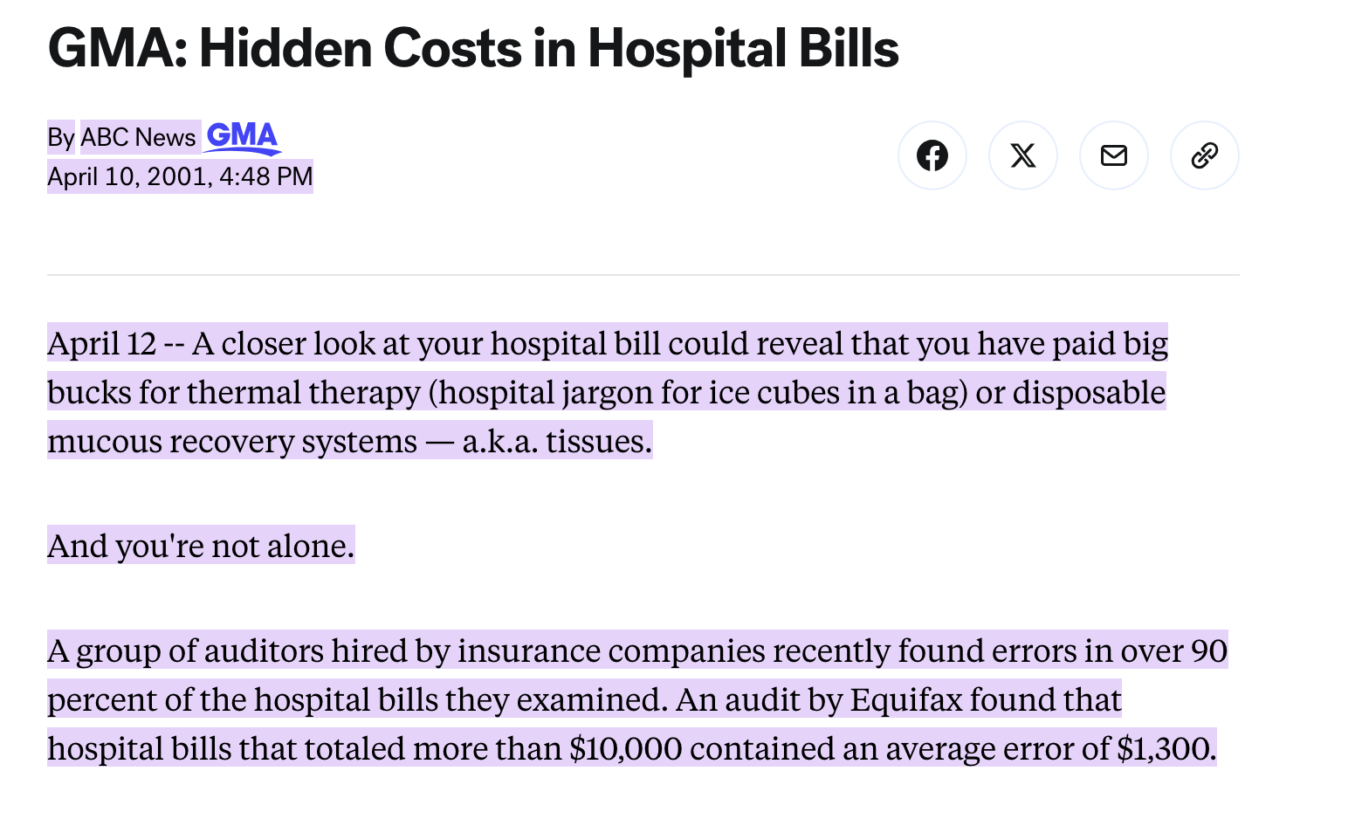

ABC News, citing Equifax data, found that hospital bills over ten thousand dollars contained an average error of about thirteen hundred dollars.  
  
For patients, that’s money lost to coding mistakes, duplicate charges, or improper bundling.

## Scene 4 – $68 Billion System Cost

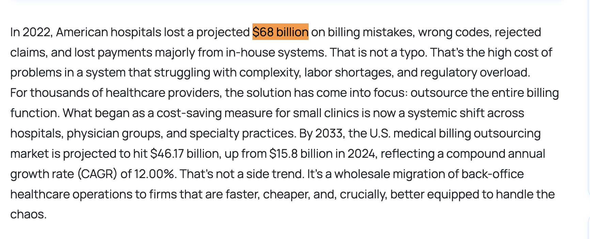

In 2022, American hospitals lost a projected sixty-eight billion dollars due to billing mistakes, rejected claims, and payment errors.  
  
This isn’t just a patient issue. It’s a system-level inefficiency problem.

## Scene 5 – $78,000 Human Impact (KFF Health News)



A KFF Health News investigation documented a Medicaid patient who suffered a heart attack while traveling and was left owing nearly seventy-eight thousand dollars. Was this in error?  
  
Errors propagate — across providers, insurers, and patients — and they’re difficult to untangle once embedded in the billing chain.

## Scene 6 – Solution Transition

Despite this prevalence, patients are expected to interpret itemized charges, insurance adjustments, and compliance codes on their own.  
  
I built MedBillDozer to put consumers in the seat of a bulldozer — with the visibility and control to systematically clear billing errors from their financial path

**Splash Screen Introduction**

Billie: Ready to see how easy it is to double-check your bills?

Billy: We scan medical bills, pharmacy receipts, dental claims, and insurance statements to uncover overcharges, duplicates, and missed reimbursements.

Billie: Hi! We’re Billy and Billie—your guides to finding billing mistakes.

**Application Tour**

## Step 1: Welcome to MedBillDozer

Welcome to MedBillDozer. If you have ever tried to reconcile a medical bill, an insurance explanation, and a pharmacy receipt at the same time, you already understand the frustration this app is designed to solve. MedBillDozer turns that manual reconciliation process into a structured, transparent workflow.

## Step 2: Demo Proof-of-Concept Workflow – Copy & Paste

## This demo workflow allows you to see exactly how documents move through the system. Click “Copy Document” on any sample file and paste it into the input fields below. You can add additional documents anytime using the plus icon. This provides a transparent view of how documents are processed within the pipeline.

## Step 3: Multi-Document Observability

When you analyze multiple documents together, the system compares what was billed, what was covered, and what was paid across providers and dates of service. You can inspect the execution graph — a visual representation of the processing steps — to see exactly how each stage runs in a deterministic pipeline, meaning the same input always produces the same result.

## Step 4: Demo Production Workflow

The Demo Production Workflow simulates how a healthcare consumer could use the system in a structured, real-world scenario. Documents are preloaded and persist state across sessions, minimizing repetitive input. Each document can carry workflow states such as ignored, resolved, or follow-up, helping consumers track which billing issues still need attention. During analysis, potential errors are flagged automatically. If a document already has a defined state, it is excluded from re-analysis to preserve deterministic processing—what data scientists and engineers call idempotency. After analysis, states can be updated through the action dropdown, and follow-up issues can be downloaded, making it simple for an individual to organize, document, and act on billing disputes with confidence.

## Step 5: Sidebar Navigation & AI Agent

The left sidebar acts as your control center. You can navigate the application, access different workflows, or ask the AI Agent questions about your documents and flagged findings.

## Step 6: Profile & Data Import

In the Profile section, you can import receipts or structured transaction data from insurance companies or providers. This allows the system to interpret new documents with the right coverage and provider context.

## Step 7: Interactive API (Application Programming Interface) Documentation

The API Documentation page provides a Swagger-like interactive explorer built entirely in Streamlit. You can browse available endpoints, inspect request and response schemas, and execute live calls directly in the browser.

This includes listing entities, ingesting documents, retrieving normalized data, checking import status, and reviewing import history. The interface mirrors production-style API documentation while allowing hands-on testing without requiring authentication in demo mode.

## Step 8: Re-Analyze Newly Loaded Documents

After importing new data, return to Home and run the Demo Production Workflow again. The system will now analyze your newly loaded documents using the same structured pipeline.

## Step 9: Take Action on Findings

Once results appear, click Actions on any flagged item to decide next steps. You can mark it for Follow-up, Ignore it, or mark it as Resolved. This turns billing review into an actionable workflow instead of a static report.

**Step 10: Proof of Concept Vision**

This demonstration shows how billing error detection can be simplified. By combining structured ingestion, deterministic workflows, and intelligent validation, the process becomes transparent, auditable, and manageable.